Main界面

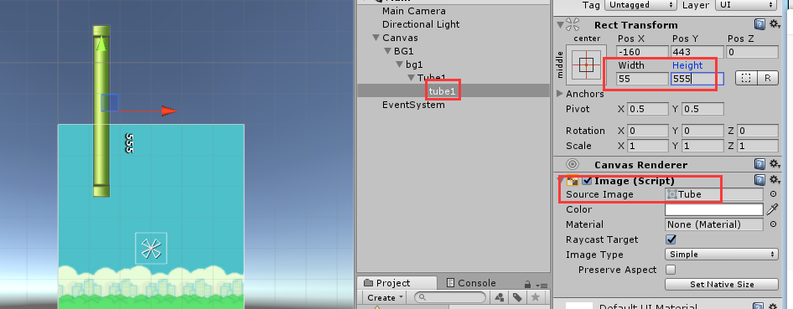

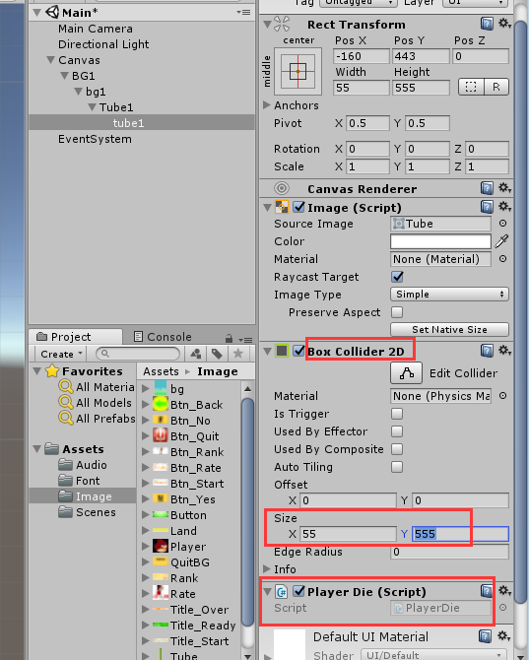

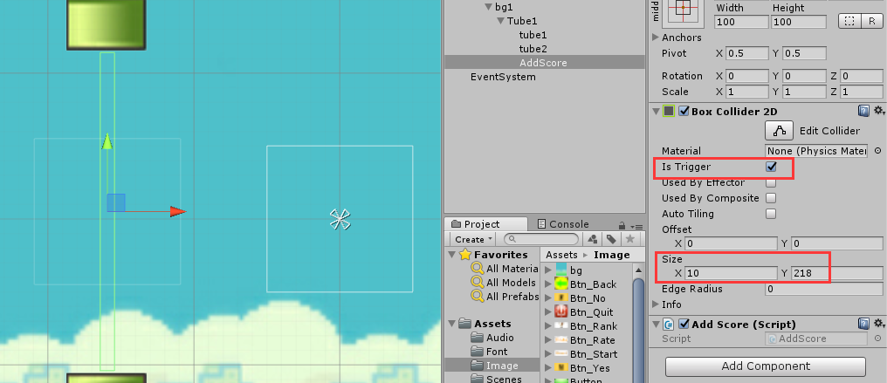

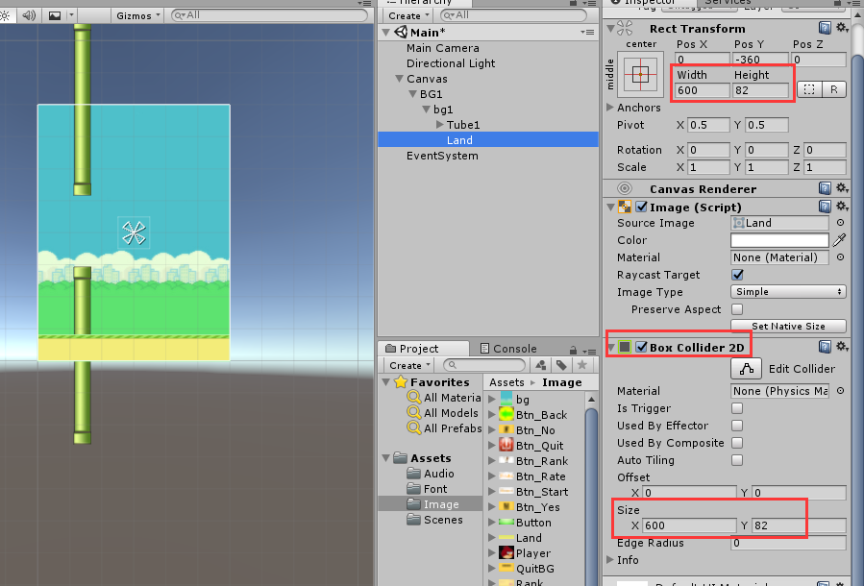

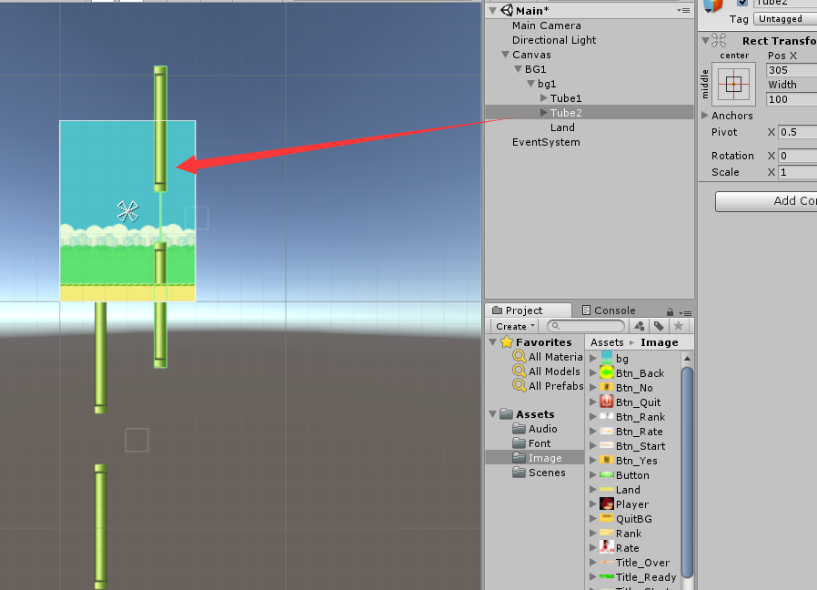

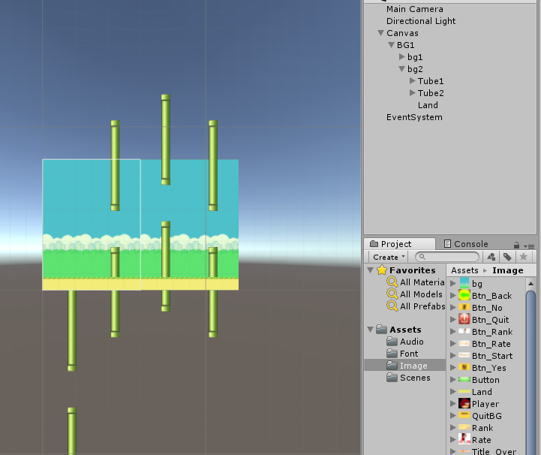

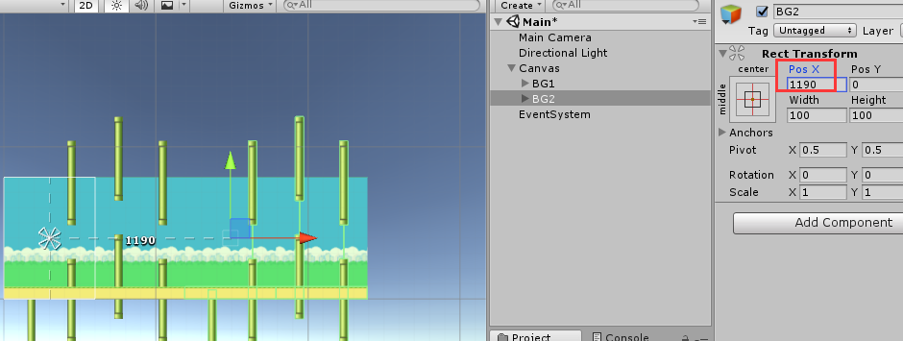

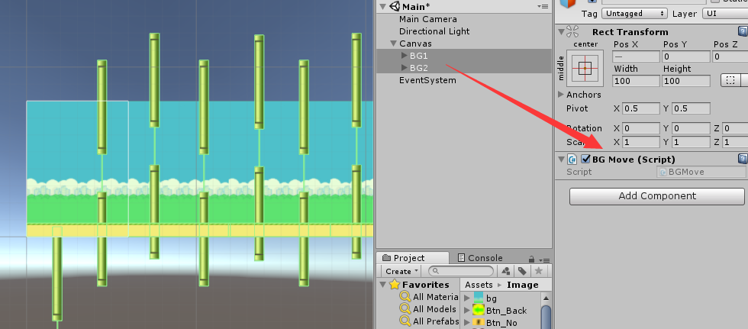

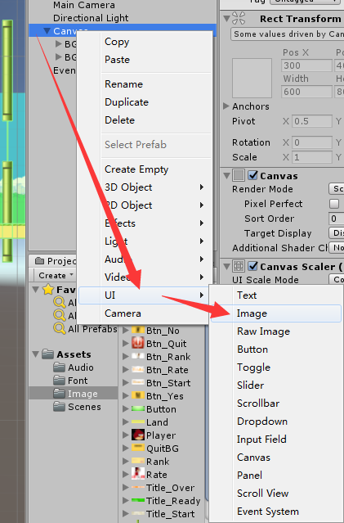

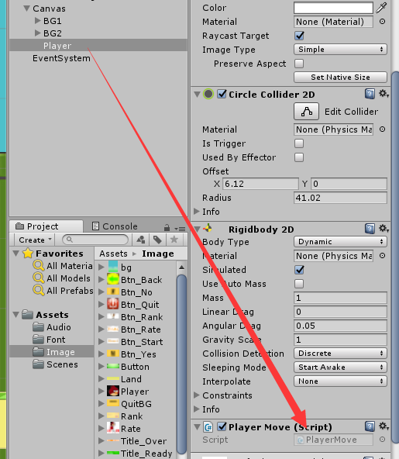

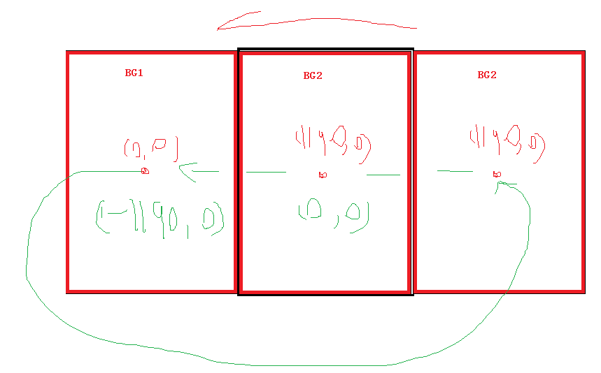

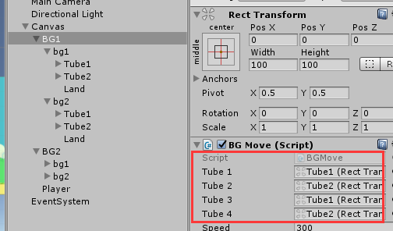

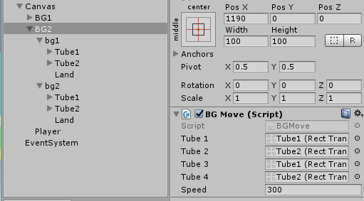

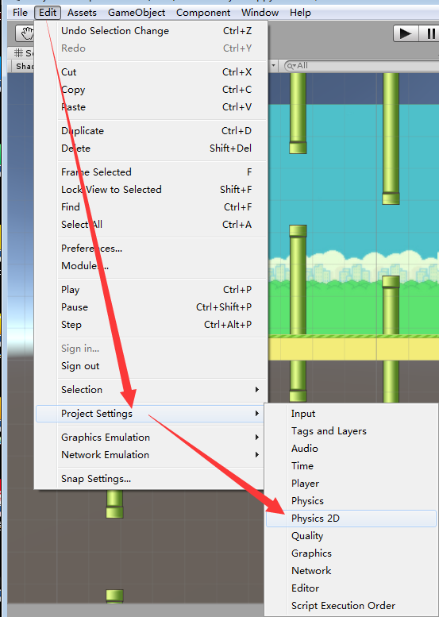

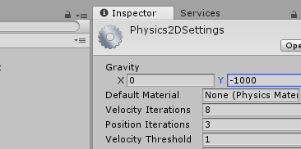

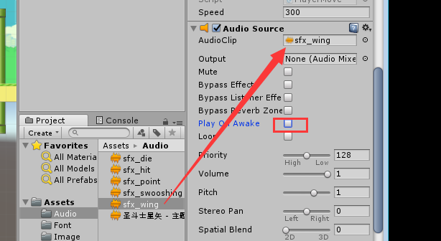

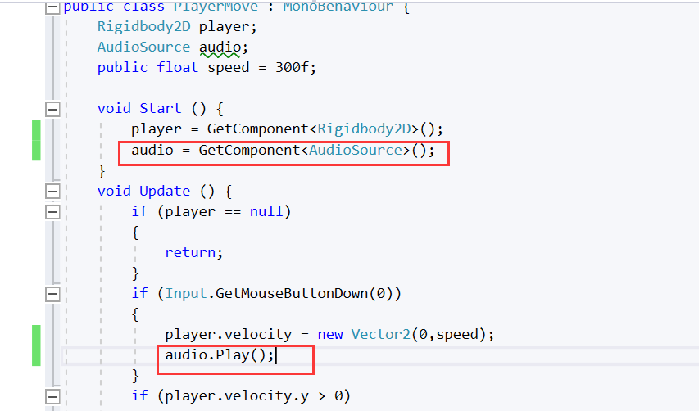

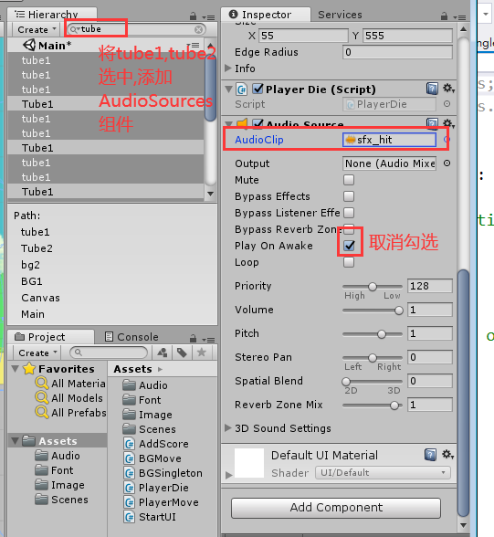

**代码：**

public class BGMove : MonoBehaviour

{

public RectTransform tube1;

public RectTransform tube2;

public RectTransform tube3;

public RectTransform tube4;

RectTransform trans;

public float speed = 300f;

void Start()

{

trans = GetComponent<RectTransform>();

}

void Update()

{

trans.Translate(Vector3.left * Time.deltaTime * speed);

if (trans.anchoredPosition.x <= -1190)

{

trans.anchoredPosition = new Vector3(1190, 0);

tube1.anchoredPosition = new Vector2(tube1.anchoredPosition.x, Random.Range(-158, 177));

tube2.anchoredPosition = new Vector2(tube2.anchoredPosition.x, Random.Range(-158, 177));

tube3.anchoredPosition = new Vector2(tube3.anchoredPosition.x, Random.Range(-158, 177));

tube4.anchoredPosition = new Vector2(tube4.anchoredPosition.x, Random.Range(-158, 177));

}

}

}

public class PlayerMove : MonoBehaviour

{

Rigidbody2D player;

AudioSource audio;

public float speed = 300f;

void Start()

{

player = GetComponent<Rigidbody2D>();

audio = GetComponent<AudioSource>();

}

void Update()

{

if (player == null)

{

return;

}

if (Input.GetMouseButtonDown(0))

{

player.velocity = new Vector2(0, speed);

audio.Play();

}

if (player.velocity.y > 0)

{

transform.eulerAngles = new Vector3(0, 0, 45);

}

else

{

transform.eulerAngles = new Vector3(0, 0, -45);

}

}

}

public class PlayerDie : MonoBehaviour

{

private void OnCollisionEnter2D(Collision2D collision)

{

if (collision.gameObject.name == "Player")

{

GetComponent<AudioSource>().Play();

//人物停止移动

//地图停止移动

}

}

}